Touchscreen Haptic Augmentation Effects on Tapping, Drag and Drop, and Path Following

Tapping Drag Following Vibration feedback

【Main Content】:

Based on the latest smartphones, combined with perfect touch sensing and haptic actuator technology, study the impact of haptic enhancement on tapping, path following and drag and drop.

(Considering user experience, not just speed and accuracy)

【Personal understanding】：

If the hand feels the texture or boundary - This is an active touch.

If it ’s the phone ’s vibration - It ’s passive tactile.

If you click the button, you have both active-feeling on the phone screen and passive-button feedback.

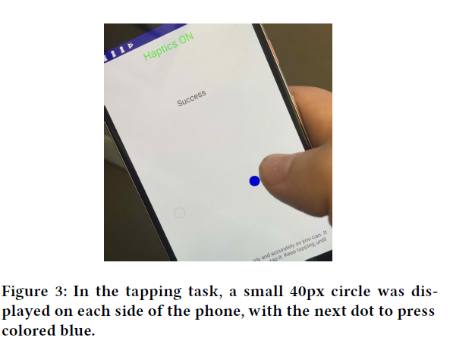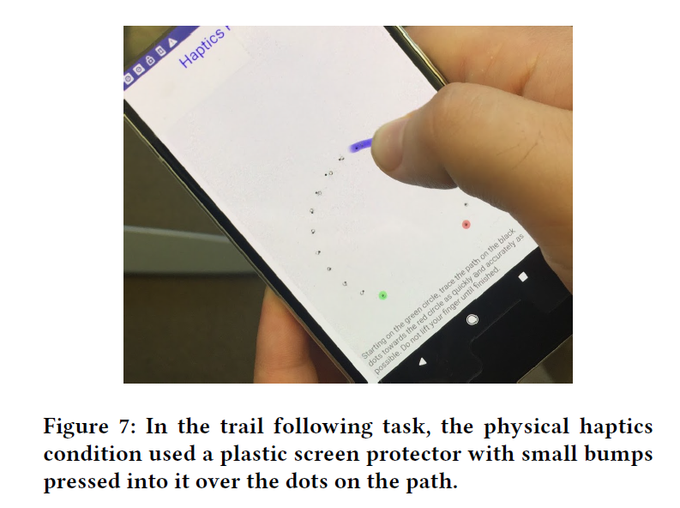 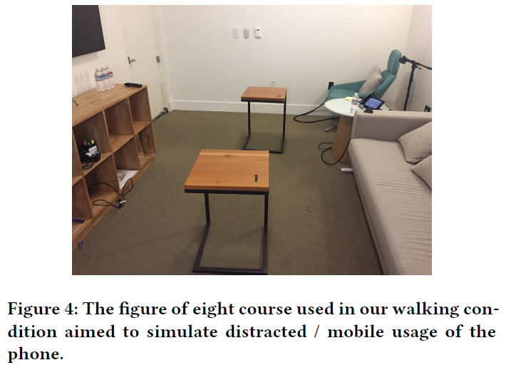

【Experiments】：(Note: the consideration of the surrounding environment is the focus when conducting the experiment)

1. **TAPPING** Click on the circle target

Two indicators: distance and time

Independent variable:

Virtual tactile vs Vision

Sitting vs Walking

Results: In sitting or walking conditions, haptic feedback does not improve tapping performance. All in all, the haptic enhancement of a click target on a touch-based touch screen cannot improve click performance.

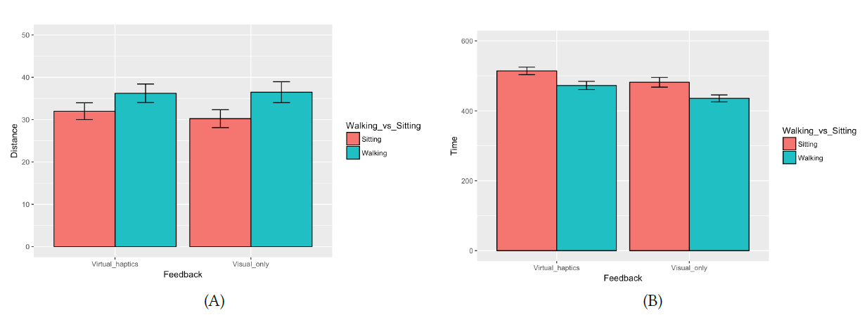

1. **DRAG & DROP** Drag a small black circle and put it into the larger target circle on the right side of the touch screen

Two indicators: success rate and time

Independent variable:

Radius

Results: Improved task performance

(In addition, some analyses of participants' subjective use feelings were also conducted.)

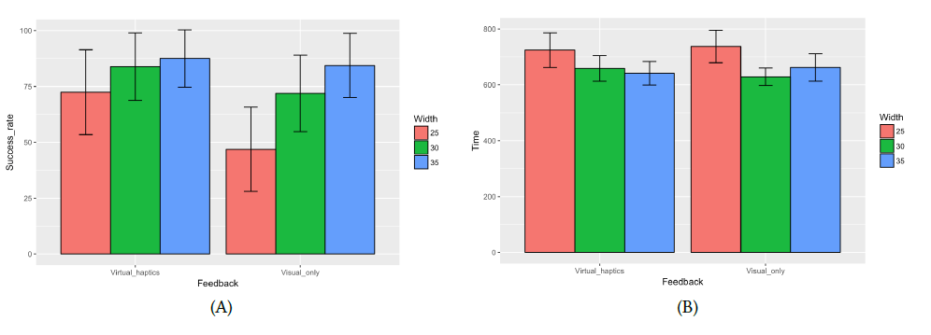

1. **The effect of touch on continuous finger movements on the touch screen, such as volume control**

Independent variable:

Feedback conditions-visual, virtual haptics and real / physical haptics

Results:

Combined with the accuracy results, this experiment shows that virtual haptics introduces a speed/accuracy tradeoff in trail following tasks, while its physical counterpart afforded even higher accuracy without significantly higher time cost.

【Subjective analysis】：

Advantage:

1. The relationship between different operations (TAPPING DRAG TRAIL FOLLOWING) and haptic feedback are studied separately
2. User experience, not just speed and accuracy
3. Based on currently very popular smartphones
4. Considering the target size and occlusion in the research, haptic feedback is the most effective for dragging and dropping small targets.

Disadvantages:

Experiment 1 of this article illustrates the effect of passive feedback on vibration on several operations, but it does not explain whether the feedback of active feedback, simulated boundaries or touch + click feedback can affect the above operations.

【Important Reference】:

[3] Motoyuki Akamatsu and I Scott MacKenzie. 1996. Movement charac-teristics using a mouse with tactile and force feedback. International Journal of Human-Computer Studies 45, 4 (1996), 483–493.

[15] Hsiang-Yu Chen, Jaeyoung Park, Steve Dai, and Hong Z Tan. 2011. De-sign and evaluation of identifiable key-click signals for mobile devices. IEEE Transactions on Haptics 4, 4 (2011), 229–241.